Operation Control Unit (OCU) Replacement Instructions

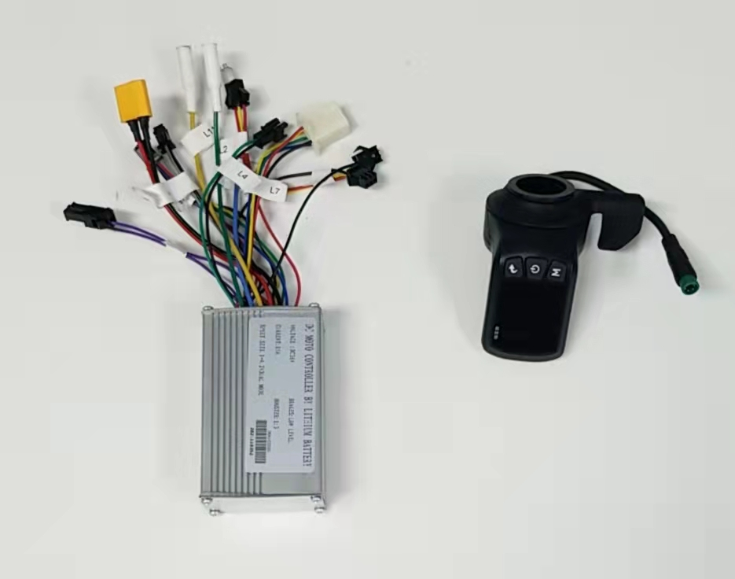

1. First, you will want to lay your EZ-Ride on a flat surface like a table or workbench and take the top panel off your EZ-Ride to get to the Control Unit.

\*\*\*If you pull off the top panel of your EZ-Ride and you only see a battery and not the OCU then you have to take off the bottom panel near the wheel to get to the OCU\*\*\*

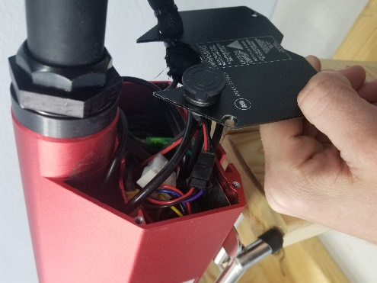

1. Gently start pulling out the wires to get to the Control unit. Avoid rubbing the wires against sharp metal surfaces! Once you can see the metal divider that divides the control unit from the battery you can slide it out slightly as shown below:

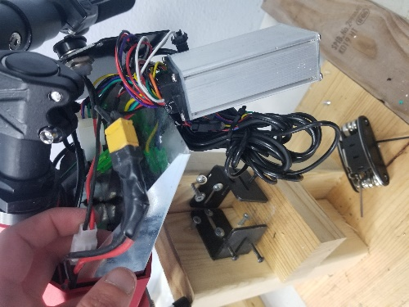

1. Starting with the battery (Orange/Yellow Connector), disconnect the wires from the OCU that needs to be replaced and reconnect the replacement OCU as follows below:

* L1 (Purple) 🡪 Connected to itself (Purple)
* L2 (Red, Yellow, Red) 🡪 (Green, Red, Black)
* L3 (Red, Yellow, Black) 🡪 (Black, Blue, Red)
* L4 (Green, Black) 🡪 (Green, Yellow)
* L5 (Black, Grey) 🡪 (Black, Yellow)
* L6 (Yellow, Green, Black, Blue, Red) 🡪Only other 5 pin connecter (Wire colors may vary)
* L7 (Blue, Green, Yellow, Black, Red) 🡪 (Green, Yellow, Blue, Black, Red)
* L8 (Black, Red) 🡪 To battery (connect after all other connections have been made)
* L9 (Blue) 🡪 (Blue)
* L10 (Green) 🡪 (Green)
* L11 (Yellow) 🡪 (Yellow)

1. Once everything is connected properly, it is time to switch out your LCD Speedometer and throttle. Remove the end cap and foam hand grip from the handlebar with the speedometer and throttle on it. Use an M3 Hex key to loosen the speedometer and then disconnect the LCD as shown in the second image below.

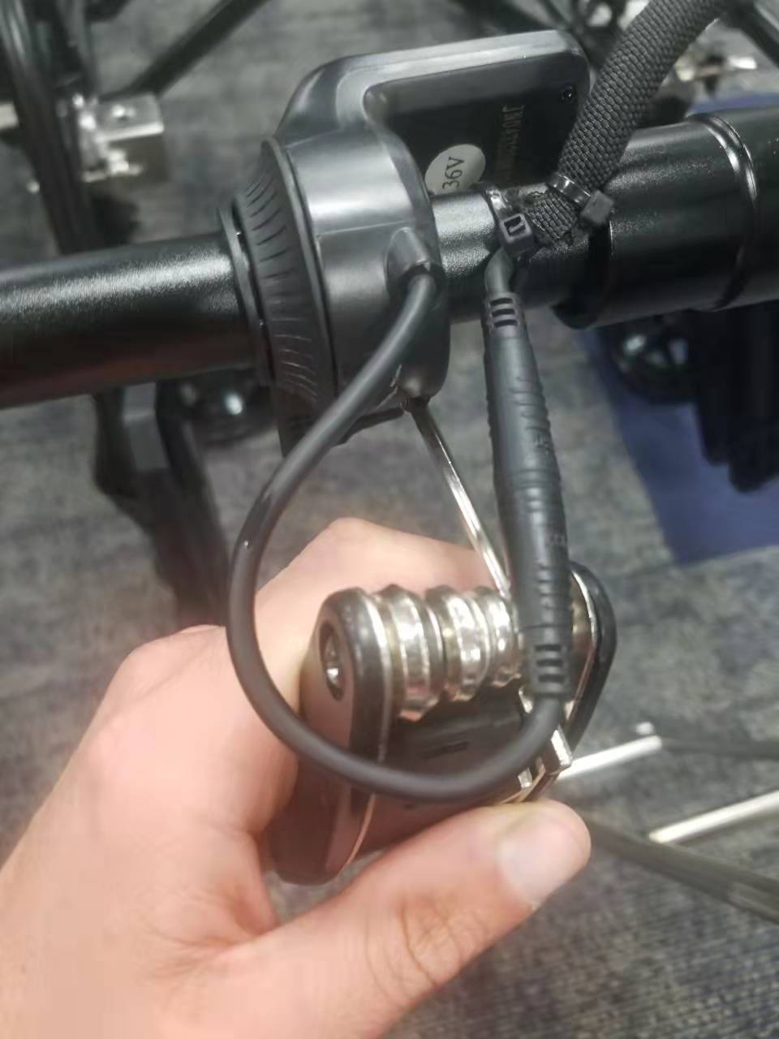 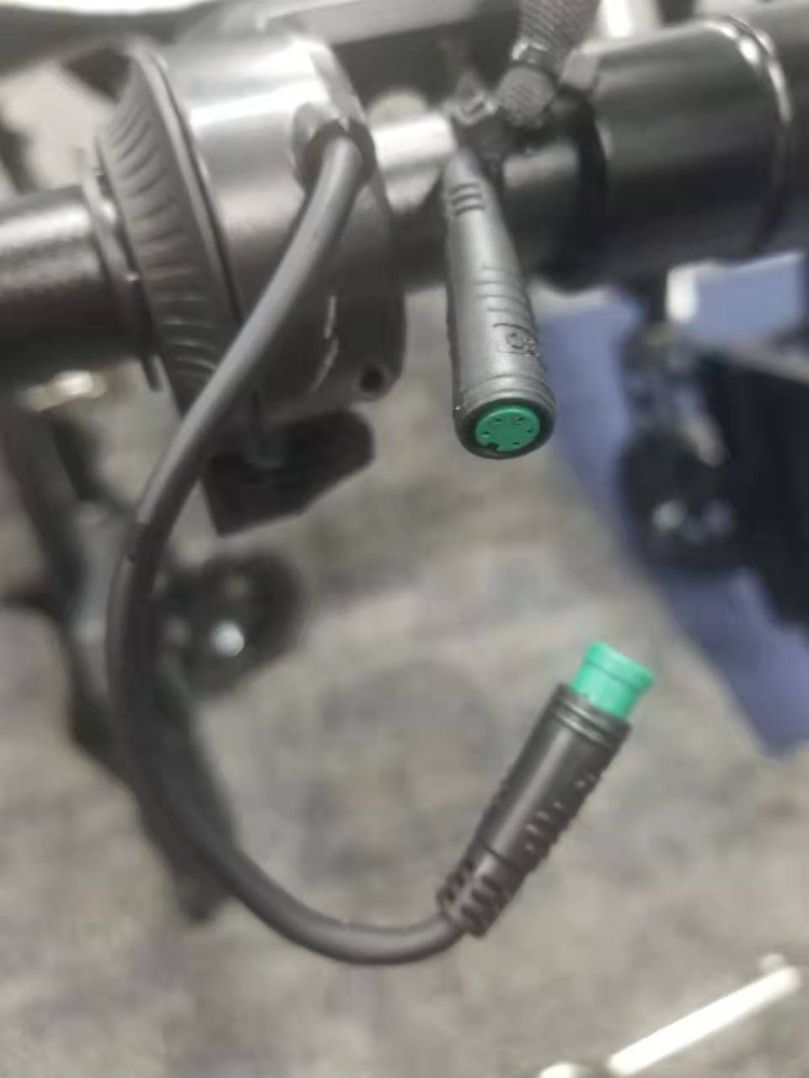

1. Slide your new speedometer and throttle onto the handlebar and reconnect the speedometer wire to the EZ-Ride.
2. Once both parts (OCU and Speedometer) have been replaced and all connections have been made, turn on the EZ-Ride.

1. Make sure there are no wires near the wheel if the OCU was at the bottom of the EZ-Ride. Make sure the EZ-Ride is switched into Drive Mode (D) and push down the throttle to see if the motor turns. Repeat this for low, medium, and high speeds.
2. If everything is working correctly (Electric motor, light, horn) then put everything back into the EZ-Ride as it came carefully making sure to not rub wires on sharp metal surfaces.